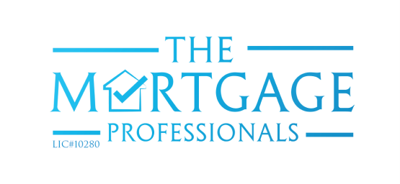

**PRESS RELEASE**  
ATTENTION ALL MEDIA  
FOR IMMEDIATE DISTRIBUTION

**Southeastern Ontario’s Largest Mortgage Brokerage Announces New Ownership**(KINGSTON) The region’s largest mortgage brokerage, The Mortgage Professionals, has announced four new owners: Hernan Parada, Karen Matthey, Leigh Graham, and Leo Ragusa. The group has 40+ years’ experience in the mortgage industry.   
  
Outgoing owners Brian Matthey and Ian Rundle will hand over the leadership of The Mortgage Professionals as of June 2017, while Alan Paterson will remain an owner until January 2018. All three will stay on as Mortgage Brokers.   
  
“We are excited for this new chapter in the history of our company. We are confident that the new owners will continue our reputation as professional, reliable mortgage brokers - a reputation we’ve earned locally over three decades,” said Brian Matthey.  
  
Founded in 1989, The Mortgage Professionals has grown to over 30 staff across 5 offices from Kingston to Gananoque. They are known for giving back to the community by supporting local business and charities, including being the title sponsor to the Down Syndrome Association of Kingston and raising funds in the Breast Cancer Action Walk for 24 years. They have also won many national awards, including Mortgage Brokerage of the Year.   
  
“It’s an honour to lead The Mortgage Professionals and build on its outstanding reputation. We will continue to work with our agents to offer exceptional service to our clients. Now more than ever, our friendly and flexible approach will help us exceed our client’s expectations, whatever their mortgage needs,” say Parada, Matthey, Graham, and Ragusa.  
  
-30-  
  
**Media Contact:**Karen Matthey  
(613) 893-4139